MINUTE

Date: | 01/11/2019 | Ref:
To: | Barwick and Scholes
CC:
From: | Adele Fox |  |  | Telephone: | 101/ 999
Subject: | Crime Report for October 2019

THEFT FROM VEHICLE
Leeds Road, Scholes
Occurred between 18.45 on 09/10/2019 and 02.00 on 10/10/2019
Between times stated the vehicle was parked locked and secure at the victims address when suspect has gained access to the vehicle and taken the victim’s wallet leaving unseen.

CRIMINAL DAMAGE
The Cross, Barwick
Occurred between 14.30 and 17.00 on 14/10/2019
Every weekday between 3pm and 5pm, various youths attend the beer garden area, they have carved writing into the tables and put burn marks on the furniture.

BURGLARY RESIDENTIAL
Main Street, Barwick
Occurred at 02.47 on 29/10/2019
No exact details on our systems as to what has happened and what has been taken. Posted on community Facebook page by local resident asking for anyone to come forward who may have seen anything at the time.

Due to the winter months now been upon us please see the following crime prevention advice with regards to protecting your property. Thank you.

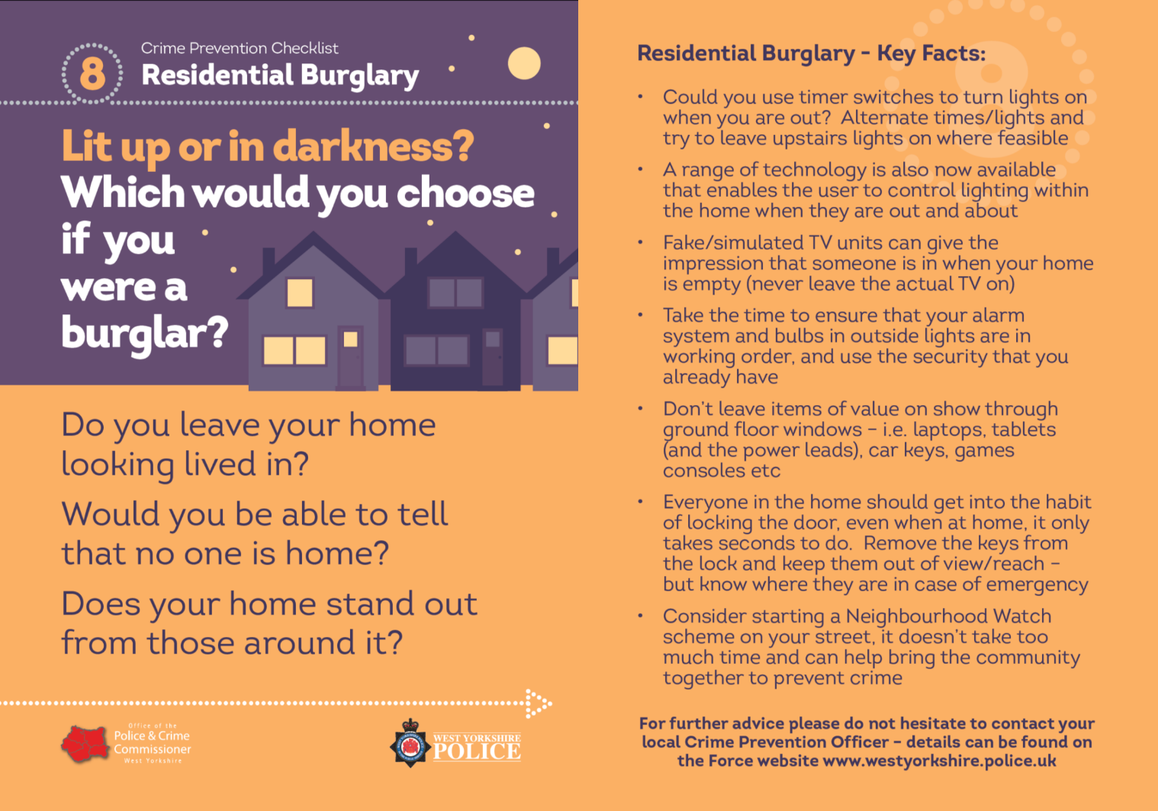

To report a crime, please ring 101 or report via our webchat service on the West Yorkshire Police website. Always dial 999 in an emergency.

For the latest news and updates:
Visit our website - www.westyorkshire.police.uk
'Like' us on Facebook - westyorkshirepolice | 'Follow' us on Twitter - @WestYorksPolice | 'Watch' us on YouTube www.youtube.com/999

