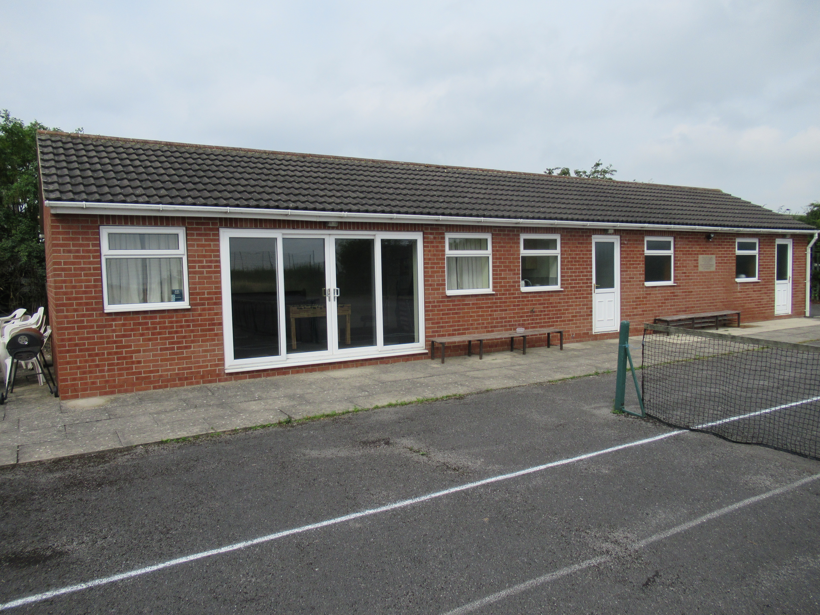
Draft Sports Pavilion Agenda

7th July 7:00 pm using Zoom virtual meeting

Agenda

1. Apologies for absence.

2. Approve Minutes of last meeting.

3. Co opt Pavilion User Representative from Beyond Inspired to committee.

4. Update members on previously agreed improvements by full PC with National Lottery Grant received February 2020.
Warm air curtain above door.
Water Heater for pavilion.
Vertical blinds for pavilion entrance.
Quotes received for electrical work.

5. Resolution to remedy the lack of lighting for car park.

6. Shadwell Junior Footballers and Mount St. Mary’s.

7. Update on “Vision for the Future”

Discuss any alternative proposals for layouts and options.

CIL Money request, other funding ways to be progressed.
Sport England
Emmerdale Fund
Balfour Beatty- Tesco
LCC Wellbeing Fund -( Cllr Maude )
Jimbo’s Fund
Community Festival Fund.

Progress so far.

8. Hedges, trees and weed control.

9. Items for inclusion at next meeting.

10. Date of next meeting.

