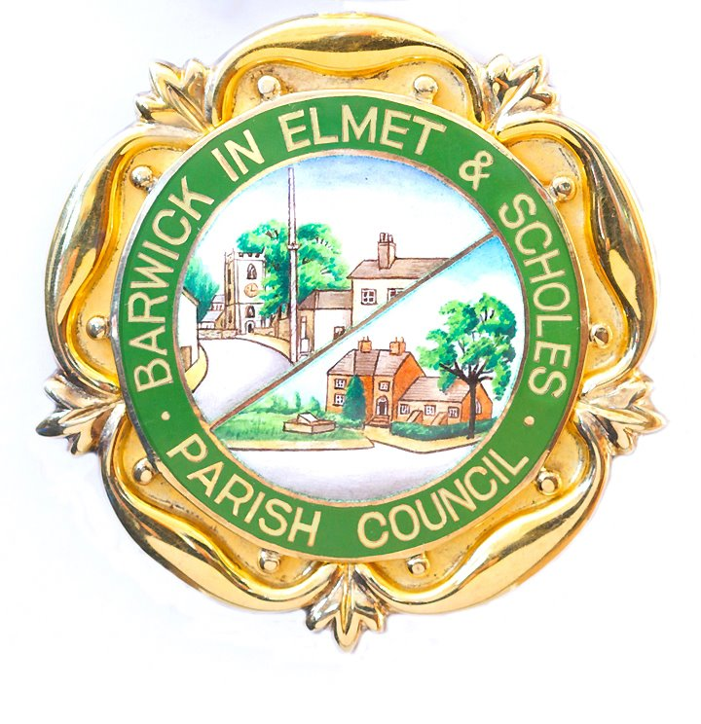
Important notification regarding the playgrounds in Barwick and Scholes.

Parish Council notification, dated 27th July 2020
Although some children’s play areas and playgrounds in Leeds began to reopen from Thursday 23rd July 2020, Barwick and Scholes Playgrounds both remain closed and cannot be used at this time.

The Scholes Playground is owned by Leeds City Council. The Barwick Playground is owned by Barwick In Elmet and Scholes Parish Council. Reopening the Barwick Playground was discussed at the Parish Council’s Extraordinary meeting held on Monday 27th July 2020.

At this meeting your Parish Council voted not to reopen the Barwick Playground yet. It was resolved to keep the Barwick playground closed due to government guidelines and to reopen it when Leeds City Council opens the playground at Scholes.

Background
Leeds City Council set the reopening programme of its 200 play areas and outdoor gyms across Leeds (with over 2,000 pieces of equipment) to be gradual to ensure that playgrounds meet the requirements set out in the government guidelines around cleaning and social distancing.

Leeds City Council believes that it will take time to safely reopen all of the play areas and playgrounds.

On Thursday 23 July 2020, Leeds City Council reopened the following parks:

- The playground at the Arium, Thorner Lane;
- The playground and adventure playground at Lotherton Hall;
- The playground at Middleton Park;
- The two playgrounds at Roundhay Park, along with outdoor gym equipment;
- The playground at Temple Newsam

Signage has been installed on the sites to remind users regarding social distancing and hygiene.

It should be noted that:
- Food and drink must not be consumed;

- Numbers of simultaneous users of the relevant pieces of equipment is limited;

- These playgrounds and items of equipment will not be supervised. They will rely on people acting responsibly;

- If these playgrounds or equipment are busy, then people should be patient to enable social distancing;

- In some cases it may be necessary to remove some swing seats to ensure social distancing is maintained.

Leeds City Council will continue to monitor government guidance and consideration will be given to reopening further playgrounds once all appropriate work and checks have been carried out. For the time being all other playgrounds and play areas will remain closed, and the public is asked to refrain from using them.

This closure applies to the Scholes Playground.

Your Parish Council will continue to watch the progress of the reopening programme in order to make the parish’s assets available for use at the soonest opportunity.

