BARWICK in ELMET & SCHOLES PARISH COUNCIL

MINUTES of a meeting of the Scholes Sports Pavilion Committee held on 10th June 2020 at 7pm using remote access

Present Cllrs. Graham Slater, Phil Maude, Howard Bedford.

John Moreland (Resident)

Cllr. Stella Walsh joined at 7:25 pm.

1 ELECTION OF CHAIR. Cllr. Slater was nominated for the office of Chair. There being no other nominations he was duly elected.
.2 APOLOGIES. None all members present.

3 DECLARATIONS OF PECUNIARY INTEREST. None.

4. TERMS OF REFERENCE.
After discussion with some amendments all agreed to the Terms of Reference that had been circulated prior to the meeting

5. Budget
It was unanimously agreed that a budget of £1500 be set for upkeep and maintenance of the pavilion and tennis courts area. A further £1,000 added for an ad-hoc self employed cleaner who would invoice the Parish Council for work done.

6. Risk assessments.
It was confirmed that risk assessments had been completed for the pavilion including further assessments for the fences, gates and barriers.

7. Co-option of residents.
It was unanimously agreed that the committee would be enhanced with the addition of more residents and in particular having a representative of users of the pavilion. The chair agreed to contact Beyond Inspired and the sewing club to extend an invitation to apply for committee membership.

8. Vision for the future of the Pavilion and Tennis Courts.
A report had been circulated prior to the meeting which outlined the facilities in Scholes compared to those provided by the three nearest parishes. It was unanimously agreed that Scholes & Barwick were far behind and that a proposal to install outdoor gym equipment, a MUGA pitch and a new tennis court be investigated further. Preliminary site plans for the alternative use of the tennis court areas to be circulated for discussion at the next meeting. Consultation will then be sought with the residents along with obtaining agreement in principle from the full Parish Council for the use of some CIL funds to take things forward. Cllr. Maude agreed to contact ward Cllr. Robinson to open dialogue for LCC or ward Wellbeing funds being available for the project.

9. Matters from Covid-19.
Beyond Inspired requested that in line with government guidelines they be allowed to return to the pavilion from 15th June. 5 Star Sports had also requested to use the football field only from 4th July. The clerk had already agreed to the requests using his delegated powers and all present were in agreement so long as all government guidelines are adhered to. It was noted that the existing multiple session agreements will expire at the end of June and new agreements are to be negotiated.
It was noted that a Covid-19 continuity grant for £10,000 had been received.

10. Upgrade program using National Lottery Grant.
Cllr. Slater gave a brief update on the usage of the £1,000 National Lottery grant that had been received in February. Upgrade to heating, lighting and water heating are in progress.

11. Date of Next Meeting.
Next meeting date 7th July at 7:00pm

Agreed 7th July
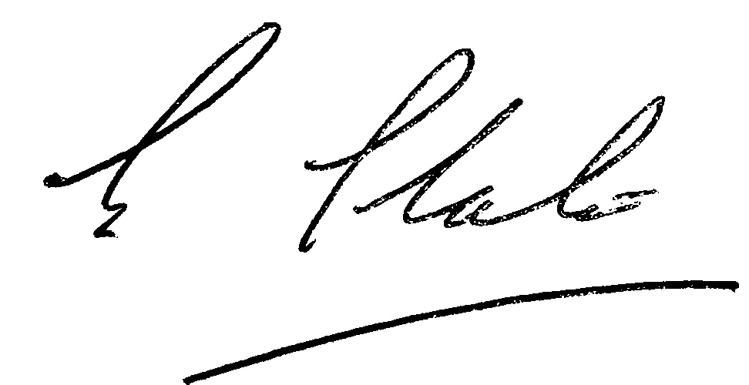

Signed

Graham Slater

