BARWICK in ELMET & SCHOLES PARISH COUNCIL

MINUTES of a meeting of the Scholes Sports Pavilion Committee held on 7th July 2020 at 7pm using remote access

Present Cllrs. Graham Slater (Chair), Phil Maude, Howard Bedford, Stella Walsh, Dan Greenwood, John Moreland (Resident), Anthony Beardsley (Pavilion User)

1. There were no apologies for absence.

2. The Minutes of last meeting of the 10th June were accepted and signed as being a true record. Proposed by and seconded by

3. Proposed by GS and seconded by PM that Anthony Beardsley be co opted as a Pavilion User Representative to the committee was unanimously approved and it was also proposed by GS and seconded by HB that Cllr. Dan Greenwood also be co opted subject to confirmation of the full Parish Council.

4. Members were updated on progress of previously agreed improvements by full PC with National Lottery Grant received February 2020 for the following;- Warm air curtain above door, Water Heater for pavilion, Vertical blinds for pavilion entrance, and Quotes received for electrical work.

5. It was resolved that lighting to the car park would be put to the F&GP committee for approval with a recommendation to accept one of the 3 quotes already received. That GS would contact LCC planning to clarify if planning approval would be required.

6. Following approval from the full PC meeting of 6th July Shadwell Junior Footballers were to be offered terms for a full season hire on Sundays from September to May with monthly payments in advance and subject to the conditions that had been circulated earlier. An email had been received earlier in the day from Shadwell confirming their wish to accept the proposal.

7. The “Vision for the Future” report was discussed and it was unanimously agreed that a shortened version this should be taken forward for approval in principle by the F&GP committee on the 14th July for the use of CIL money whilst organising a consultation document for distribution to all residents. Document which includes a questionnaire to be ready for printing by 22nd July and to be distributed immediately after printing. A residents open session for comments and alternative suggestions to be held at the pavilion on Saturday 22nd August. SW suggested that an outdoor table tennis facility be added to the proposal and would investigate possible grant funding options for this. A3 posters to be created with an artists impression of the end results of the scheme and exhibited on local notice boards and commercial establishments.

Initial indications are that the project will cost circa £80,000 + vat.
It was agreed that GS could contact Balfour Beatty to make preliminary investigations into obtaining support from them for re surfacing the whole area of the tennis courts. If unsuccessful then ward Cllr Robinson to be asked to assist via LCC.

8. John Moreland was thanked for cutting the hedge that borders on to the garden of 66 Belle Vue Avenue.

9. There were no items requested for inclusion at next meeting.

10. Date of next meeting fixed for17th August at 7:00 pm
There being no further business the meeting closed at 9:05pm.

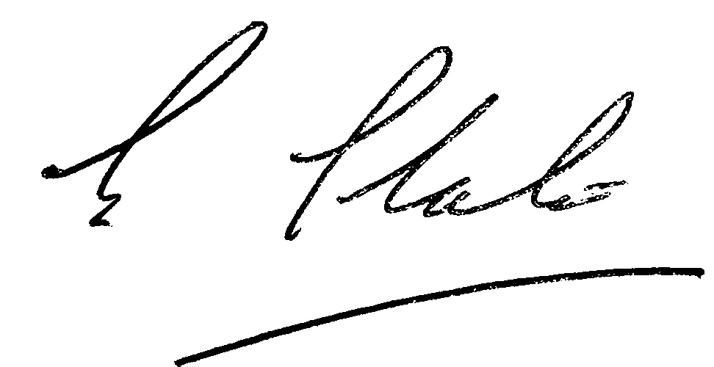
Signed Chair 18th August 2020

