Barwick in Elmet and Scholes Parish Council
Sponsorship Application Form for benches

Name…………………………………………………………………………………………………………
Address……………………………..………………………………………………………………………
Telephone number……………………… Email Address……………………..……
I wish to sponsor a bench in memory of …………………….………….…. who lived in the Parish .
I would like the following bench (please delete as appropriate)
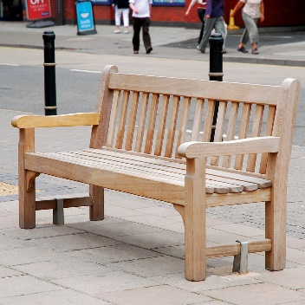 | 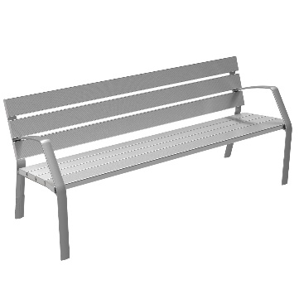 | 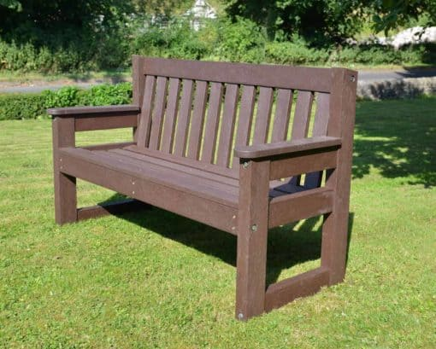 | 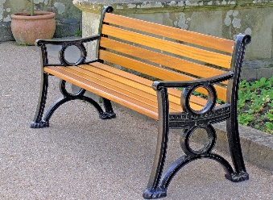
Wooden benches from sustainable sources with arm rests  Kennington Seat: BX17 4019 | Broxap | Metal benches with arm rests  Williams Aluminium Seat (streetfurnituredirect.co.uk) | Recycled plastic benches with arm rests. 1800mm.  Dale Bench | Plastic Garden Bench | TDP | Wooden benches with metal arms  Georgian Seat - Seats | Streetmaster Products

1. Wooden benches from sustainable sources with arm rests,
2. Metal benches with arm rests,
3. Recycled plastic benches with arm rests.
Note: All sponsorships will cover the costs of the bench, installation and a one-off contribution for maintaining the bench.
I would like the following words inscribed on the plaque
…………………………………………………………………………………………………………………………………………..
………………………………………………………………………………………………………………………………………………
(this should be limited to twenty words)
Terms and Conditions of Sponsorship
1. The Barwick in Elmet and Scholes Parish Council (the PC) are willing to facilitate the sponsorship of benches in the parish at locations identified by the PC and agreed as suitable by Leeds City Council.
2, Persons wishing to sponsor a bench should complete this application form and send it to the Clerk of the PC either by email at clerk@barwickandscholespc.org or by post or delivery to 33 Flats Lane Barwick in Elmet, Leeds, LS15 4LJ. He can be contacted by telephone at 0113 393 5861.
3. Applicants should indicate their preferred location for the bench but the PC reserve the right to offer another location if the preferred location is not available.
4. On receipt of the Application Form the PC will consider the application and will advise if the preferred location is available and if not which other sites are available. When a site has been agreed the PC will notify the Applicant and will advise the Applicant of the fee required. Once payment has been made the PC will order the bench and make arrangements for a plaque to be fitted to the bench with wording provided by the Applicant. The bench will be installed at the agreed location by the PC. No order will be made for a bench until payment has been made.
5. The ownership of the bench will rest at all times with the PC and the PC will be responsible for maintaining it and providing insurance cover.
6. The PC retains the right to relocate the bench if it receives persistent complaints of anti-social behaviour in the vicinity of the bench or if it is requested to do so by the police or Leeds City Council.
9, Details of available sites are shown on the PC website at Bench-Locations-in-Scholes.pdf (barwickandscholespc.org). In the event that all sites are taken the PC will set up a waiting list and will periodically consult with Leeds City Council and landowners to seek locations for additional sites. If no sites are currently available payment will not be required until the PC notifies the Applicant that a new site has become available and the Applicant has agreed to proceed at that site.
I have read and agree above terms and conditions

Signed …………………………. Date ……………………………….

